Lab 6 Functions Revisited

Instructions
- Answer the below question in the boxes if needed.
- Code on your computer and zip all your code before submission.
- Please submit the assignment after you finish.

Part 1 Functions

1.1 Code Dry-running
In this section, you don’t need to write any code. Just try to run the code in your mind or on a piece of paper. DO NOT test the code with your computer.

Question 1.1 What’s the console output of the following statements? (Hint: the results might be more than 1 line)
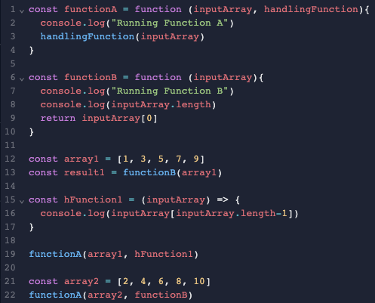

Answer 1.1

Question 1.2 What’s the console output of the following statements? (Hint: the results might be more than 1 line)
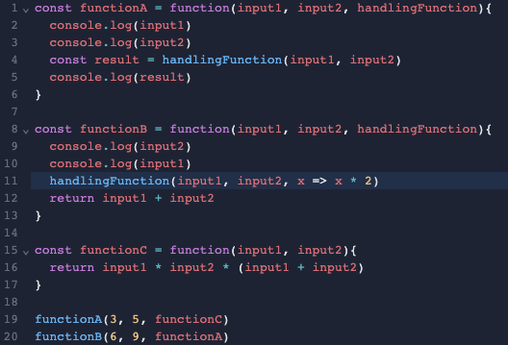

Answer 1.2

Part 2 Rewriting Functions into Arrow Functions

2.1 Code Rewriting
Please rewrite the code block below by using Arrow Functions. Then test it with repl.it.
You can paste a screenshot or type the code in the answer box.

Question 2.1.1
Original Code:
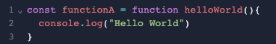
Rewritten Code:

Question 2.1.2
Original Code:
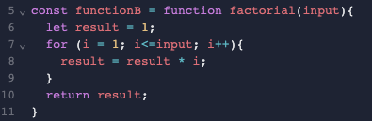

Rewritten Code:

Question 2.1.3
Original Code:
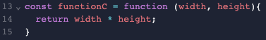

Rewritten Code:

Question 2.1.4
Original Code:
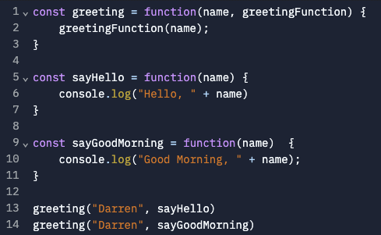

Rewritten Code:

